AWX on the AWS Cloud

Quick Start Reference Deployment

Feb 2018

*<Partner Organization>*

*AWS Quick Start Reference Team*

Contents

Overview 2

AWX on AWS 2

Costs and Licenses 3

Architecture 3

Prerequisites 5

Specialized Knowledge 5

Technical Requirements 5

Deployment Options 5

Deployment Steps 5

Step 1. Prepare Your AWS Account 5

Step 2. Launch the Quick Start 6

Step 4. Test the Deployment 9

Best Practices Using AWX on AWS 9

Security 9

<Other Useful Information> 9

FAQ 9

Git Repository 10

Additional Resources 10

Document Revisions 10

Style Guide 12

Terminology and usage 12

Bullet lists 12

Numbered lists for procedures 12

Tips, Notes, Warnings 13

Figures 13

Tables 13

References 13

Code 14

Sidebars 14

Colors 15

This Quick Start deployment guide was created by Amazon Web Services (AWS) in partnership with <partner organization>.

[Quick Starts](http://aws.amazon.com/quickstart/) are automated reference deployments that use AWS CloudFormation templates to deploy key technologies on AWS, following AWS best practices.

## Overview

This Quick Start reference deployment guide provides step-by-step instructions for deploying AWX on the Amazon Web Services (AWS) Cloud.

This Quick Start is for customers who want to run and manage Ansible AWX infrastructure on AWS. However, we recommend that you also take a look at AWS OpsWorks, which is a configuration management service provided by AWS, to determine if it's more suitable for your needs. AWS OpsWorks helps you configure and operate applications of all types and sizes. You can define the application’s architecture and the specification of each component, including package installation, software configuration, and resources such as storage. For more information, see the [AWS OpsWorks User Guide](http://docs.aws.amazon.com/opsworks/latest/userguide/).

### AWX on AWS

Ansible is an IT DevOps tool that automates provisioning, configuration management, application deployment, intra-service orchestration, continuous delivery, and many other IT processes.

Ansible is designed for multi-tier deployments. Instead of managing systems individually, it models your IT infrastructure by describing the inter-relationships among all your systems.

AWX provides a web-based user interface, REST API, and task engine built on top of [Ansible](https://github.com/ansible/ansible). It is the upstream project for [Tower](https://www.ansible.com/tower), a commercial derivative of AWX. Its visual dashboard lets you schedule and deploy Ansible playbooks, and provides centralized logging, auditing, and system tracking.

A key advantage to Ansible over other automation engines is that it uses no agents and no additional custom security infrastructure, which simplifies deployment. Ansible uses a very simple, human-readable language called YAML for Ansible playbooks, to manage configuration, deployment, and orchestration tasks. Ansible works by connecting to your nodes and running small programs, called Ansible modules, to configure the resource for your system. Ansible executes these modules over Secure Shell (SSH) by default, and removes them when finished.

### Costs and Licenses

You are responsible for the cost of the AWS services used while running this Quick Start reference deployment. There is no additional cost for using the Quick Start.

The AWS CloudFormation template for this Quick Start includes configuration parameters that you can customize. Some of these settings, such as instance type, will affect the cost of deployment. For cost estimates, see the pricing pages for each AWS service you will be using. Prices are subject to change.

Ansible is installed as part of the Ansible Tower installation and is licensed under the [GNU General Public License version 3](http://www.gnu.org/licenses/gpl-3.0.html).

AWX is licensed under Apache version 2.

## Architecture

Deploying this Quick Start for a new virtual private cloud (VPC) with **default parameters** builds the following AWX environment in the AWS Cloud.

Figure 1: Quick Start architecture for AWX on AWS

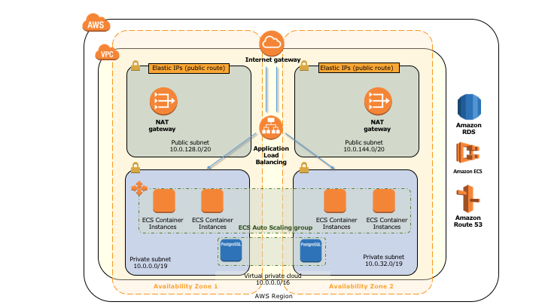

The Quick Start sets up the following:

* A highly available architecture that spans two Availability Zones.*
* A VPC configured with public and private subnets according to AWS best practices, to provide you with your own virtual network on AWS.*
* An internet gateway to allow access to the internet. This gateway is used by the bastion hosts to send and receive traffic.*
* In the public subnets, managed NAT gateways to allow outbound internet access for resources in the private subnets.*
* In the private subnets, an Amazon ECS cluster across at least 2 availability zones. If you choose an AWS Region that provides more you can utilize 3 or more.
* An Amazon RDS PostgreSQL database
* A CodeBuild project to build the AWX project from the official AWX Github repository

**\*** The template that deploys the Quick Start into an existing VPC skips the tasks marked by asterisks and prompts you for your existing VPC configuration.

## Prerequisites

### Specialized Knowledge

Before you deploy this Quick Start, we recommend that you become familiar with the following AWS services. (If you are new to AWS, see [Getting Started with AWS](https://aws.amazon.com/getting-started/).)

* [Amazon EC2](https://aws.amazon.com/documentation/ec2/)
* [Amazon VPC](https://aws.amazon.com/documentation/vpc/)
* [AWS CloudFormation](https://aws.amazon.com/documentation/cloudformation/)
* [Amazon RDS](https://aws.amazon.com/documentation/rds/)
* [Amazon ECS](https://aws.amazon.com/documentation/ecs/)

You will also need a Github account in order for CodeBuild to access the AWX project.

### Technical Requirements

*AWS account configuration, operating system, licensing, DNS, etc. requirements*

## Deployment Options

This Quick Start provides two deployment options:

* **Deploy** AWX **into a new VPC** (end-to-end deployment). This option builds a new AWS environment consisting of the VPC, subnets, NAT gateways, security groups, bastion hosts, and other infrastructure components, and then deploys AWX into this new VPC.
* **Deploy** AWX **into an existing VPC**. This option provisions AWX in your existing AWS infrastructure.

The Quick Start provides separate templates for these options. It also lets you configure CIDR blocks, instance types, and AWX settings, as discussed later in this guide.

## Deployment Steps

### Step 1. Prepare Your AWS Account

1. If you don’t already have an AWS account, create one at <https://aws.amazon.com> by following the on-screen instructions.
2. Use the region selector in the navigation bar to choose the AWS Region where you want to deploy AWX on AWS.
3. Create a [key pair](https://docs.aws.amazon.com/AWSEC2/latest/UserGuide/ec2-key-pairs.html) in your preferred region.
4. If necessary, [request a service limit increase](https://console.aws.amazon.com/support/home#/case/create?issueType=service-limit-increase&limitType=service-code-) for the Amazon EC2 instance type that will be used for the deployment. You might need to do this if you already have an existing deployment that uses this instance type, and you think you might exceed the [default limit](http://docs.aws.amazon.com/AWSEC2/latest/UserGuide/ec2-resource-limits.html) with this deployment.

### Step 2. Create an OAuth token for CodeBuild to access Github (required to build the AWX project)

1. In the AWS console, select the relevant region and switch to the CodeBuild console. In the AWS CodeBuild console, click ‘Get started’.

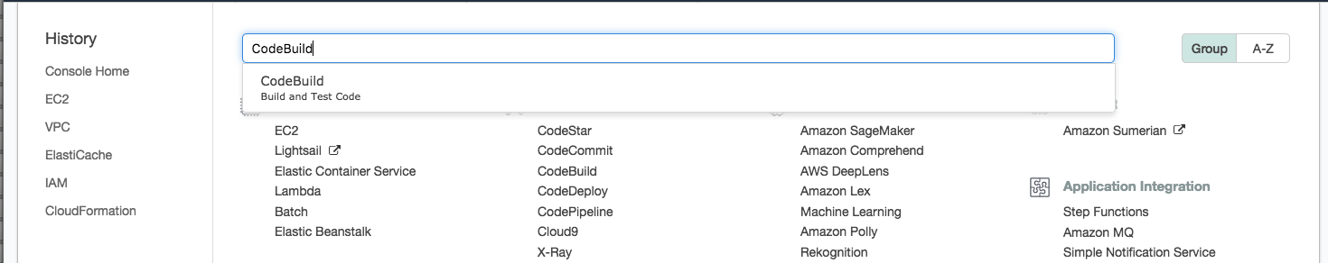

1. From the ‘Create project’ dialog, select ‘Source provider’ and then Github. From the ‘Repository’ click the ‘Connect to GitHub’ button.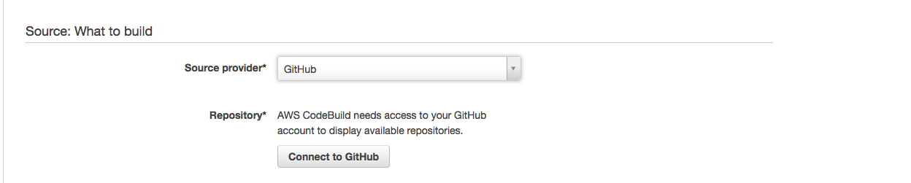
2. A new dialog will pop-up – if you would like to authorize CodeBuild to access your GitHub account (required for this QuickStart) click on ‘Authorize aws-codesuite’ – you will be prompted to confirm your GitHub password. 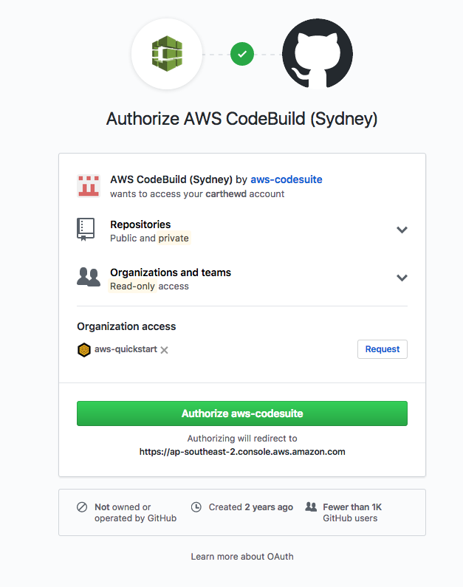
3. Once complete, you can cancel out of the ‘Create project’ dialog and continue with the QuickStart

### Step 2. Launch the Quick Start

**Note** You are responsible for the cost of the AWS services used while running this Quick Start reference deployment. There is no additional cost for using this Quick Start. For full details, see the pricing pages for each AWS service you will be using in this Quick Start. Prices are subject to change.

1. Choose one of the following options to launch the AWS CloudFormation template into your AWS account. For help choosing an option, see deployment options earlier in this guide.

|  |  |
| --- | --- |
| Option 1  [**Launch**](https://console.aws.amazon.com/cloudformation/home?region=us-east-2#cstack=sn%7EOracle-Database%7Cturl%7Ehttps://s3.amazonaws.com/quickstart-reference/)  Deploy AWX into a  new VPC on AWS | Option 2  [**Launch**](https://console.aws.amazon.com/cloudformation/home?region=us-east-2#cstack=sn%7EOracle-Database%7Cturl%7Ehttps://s3.amazonaws.com/quickstart-reference/)  Deploy AWX into an existing VPC on AWS |

**Important** If you’re deploying AWX into an existing VPC, make sure that your VPC has two private subnets in different Availability Zones for the database instances. These subnets require [NAT gateways or NAT instances](http://docs.aws.amazon.com/AmazonVPC/latest/UserGuide/vpc-nat.html) in their route tables, to allow the instances to download packages and software without exposing them to the internet. You will also need the domain name option configured in the DHCP options as explained in the [Amazon VPC documentation](http://docs.aws.amazon.com/AmazonVPC/latest/UserGuide/VPC_DHCP_Options.html). You will be prompted for your VPC settings when you launch the Quick Start.

Each deployment takes about <x> hours to complete.

1. Check the region that’s displayed in the upper-right corner of the navigation bar, and change it if necessary. This is where the network infrastructure for AWX will be built. The template is launched in the US East (Ohio) Region by default.
2. On the **Select Template** page, keep the default setting for the template URL, and then choose **Next**.
3. On the **Specify Details** page, change the stack name if needed. Review the parameters for the template. Provide values for the parameters that require input. For all other parameters, review the default settings and customize them as necessary. When you finish reviewing and customizing the parameters, choose **Next**.

In the following tables, parameters are listed by category and described separately for the two deployment options:

* Parameters for deploying AWX into a new VPC
* Parameters for deploying AWX into an existing VPC
* **Option 1: Parameters for deploying AWX into a new VPC**

[View template](https://s3.amazonaws.com/quickstart-reference/)

*<The following parameter tables are generated automatically from the templates. Don’t enter the parameter information manually. The information below is provided only as an example. We recommend that you use these group and parameter labels if you’re providing similar functionality in your CloudFormation templates.>*

*VPC Network Configuration:*

|  |  |  |
| --- | --- | --- |
| Parameter label (name) | Default | Description |
| Availability Zones (AvailabilityZones) | *Requires input* | The list of Availability Zones to use for the subnets in the VPC. The Quick Start uses two Availability Zones from your list and preserves the logical order you specify. |
| VPC CIDR (VPCCIDR) | 10.0.0.0/16 | The CIDR block for the VPC. |
| Private Subnet 1 CIDR (PrivateSubnet1CIDR) | 10.0.0.0/19 | The CIDR block for the private subnet located in Availability Zone 1. |
| Private Subnet 2 CIDR (PrivateSubnet2CIDR) | 10.0.32.0/19 | The CIDR block for the private subnet located in Availability Zone 2. |
| Public Subnet 1 CIDR (PublicSubnet1CIDR) | 10.0.128.0/20 | The CIDR block for the public (DMZ) subnet located in Availability Zone 1. |
| Public Subnet 2 CIDR (PublicSubnet2CIDR) | 10.0.144.0/20 | The CIDR block for the public (DMZ) subnet located in Availability Zone 2. |
| Permitted IP range (AccessCIDR) | *Requires input* | The CIDR IP range that is permitted to access <software>. We recommend that you set this value to a trusted IP range. For example, you might want to grant only your corporate network access to the software. |

*Amazon EC2 Configuration:*

|  |  |  |
| --- | --- | --- |
| Parameter label (name) | Default | Description |
| Key Name (KeyPairName) | *Requires input* | A public/private key pair, which allows you to connect securely to your instance after it launches. When you created an AWS account, this is the key pair you created in your preferred region. |

*AWS Quick Start Configuration:*

|  |  |  |
| --- | --- | --- |
| Parameter label (name) | Default | Description |
| Quick Start S3 Bucket Name (QSS3BucketName) | quickstart-reference | The S3 bucket you have created for your copy of Quick Start assets, if you decide to customize or extend the Quick Start for your own use. The bucket name can include numbers, lowercase letters, uppercase letters, and hyphens, but should not start or end with a hyphen. |
| Quick Start S3 Key Prefix (QSS3KeyPrefix) | atlassian/bitbucket/latest/ | The [S3 key name prefix](https://docs.aws.amazon.com/AmazonS3/latest/dev/UsingMetadata.html) used to simulate a folder for your copy of Quick Start assets, if you decide to customize or extend the Quick Start for your own use. This prefix can include numbers, lowercase letters, uppercase letters, hyphens, and forward slashes. |

* **Option 2: Parameters for deploying** AWX **into an existing VPC**

[View template](https://s3.amazonaws.com/quickstart-reference/)

*<The following parameter tables are generated automatically from the templates. Don’t enter the parameter information manually. The information below is provided only as an example. We recommend that you use these group and parameter labels if you are providing similar functionality in your CloudFormation templates.>*

*Network Configuration:*

|  |  |  |
| --- | --- | --- |
| Parameter label (name) | Default | Description |
| VPC ID (VPCID) | *Requires input* | The ID of your existing VPC (e.g., vpc-0343606e). |
| Private Subnet 1 ID (PrivateSubnet1ID) | *Requires input* | The ID of the private subnet in Availability Zone 1 in your existing VPC (e.g., subnet-a0246dcd). |
| Private Subnet 2 ID (PrivateSubnet2ID) | *Requires input* | The ID of the private subnet in Availability Zone 2 in your existing VPC (e.g., subnet-b58c3d67). |
| Bastion Security  Group ID  (BastionSecurityGroupID) | *Requires input* | The ID of the bastion security group in your existing VPC (e.g., sg-7f16e910). |

*Amazon EC2 Configuration:*

|  |  |  |
| --- | --- | --- |
| Parameter label (name) | Default | Description |
| Key Pair Name (KeyPairName) | *Requires input* | A public/private key pair, which allows you to connect securely to your instance after it launches. When you created an AWS account, this is the key pair you created in your preferred region. |

1. On the **Options** page, you can [specify tags](https://docs.aws.amazon.com/AWSCloudFormation/latest/UserGuide/aws-properties-resource-tags.html) (key-value pairs) for resources in your stack and [set advanced options](https://docs.aws.amazon.com/AWSCloudFormation/latest/UserGuide/cfn-console-add-tags.html). When you’re done, choose **Next**.
2. On the **Review** page, review and confirm the template settings. Under **Capabilities**, select the check box to acknowledge that the template will create IAM resources.
3. Choose **Create** to deploy the stack.
4. Monitor the status of the stack. When the status is **CREATE_COMPLETE**, the AWX cluster is ready.
5. Use the URLs displayed in the **Outputs** tab for the stack to view the resources that were created.

### Step 4. Test the Deployment

*Add steps as necessary for accessing the software, post-configuration, and testing.*

To access the AWX environment you can access the ALB endpoint created during the deployment – once the ‘migration’ step is complete you can use the AWX credentials defined during your deployment.

1. Locate the ALB address from the ‘outputs’ section in the CloudFormation stack.
2. Using your preferred web browser, browse to the ALB URL from the ‘outputs’ section of the QuickStart deployment.
3. You will see the ‘AWX’ migration screen while the setup is being finalized.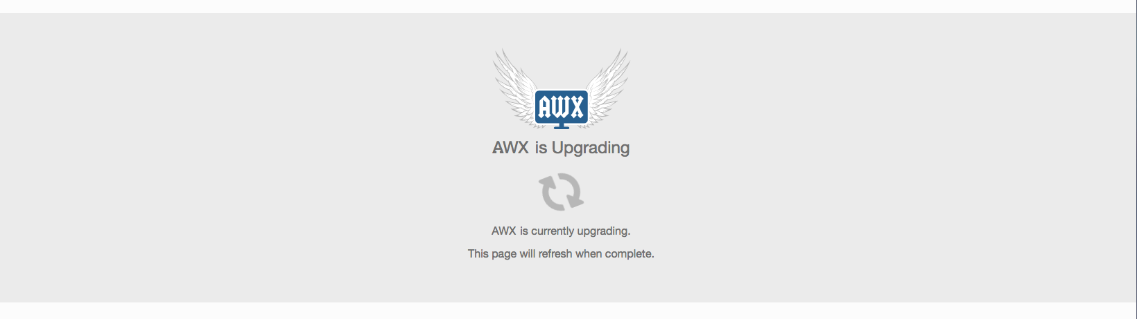
4. Once this process is complete, you will be presented with the login page.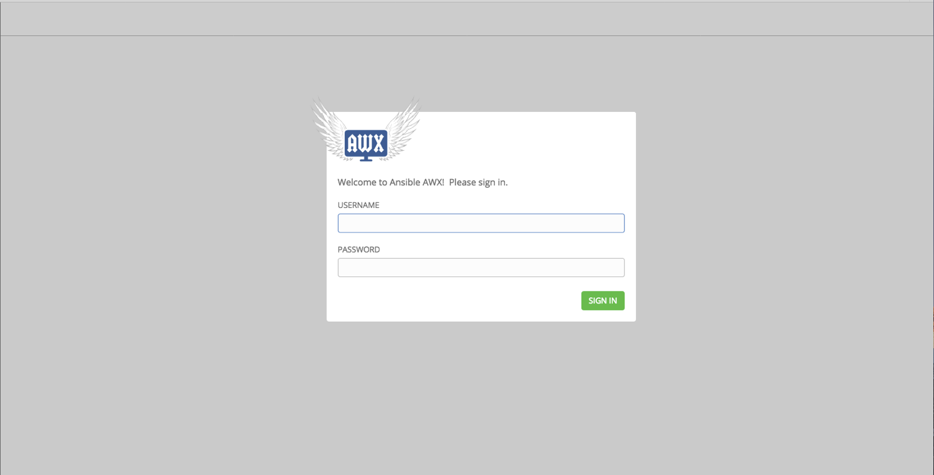
5. Use the AWX username/password you specified during the QuickStart launch steps (default AWX username is admin). 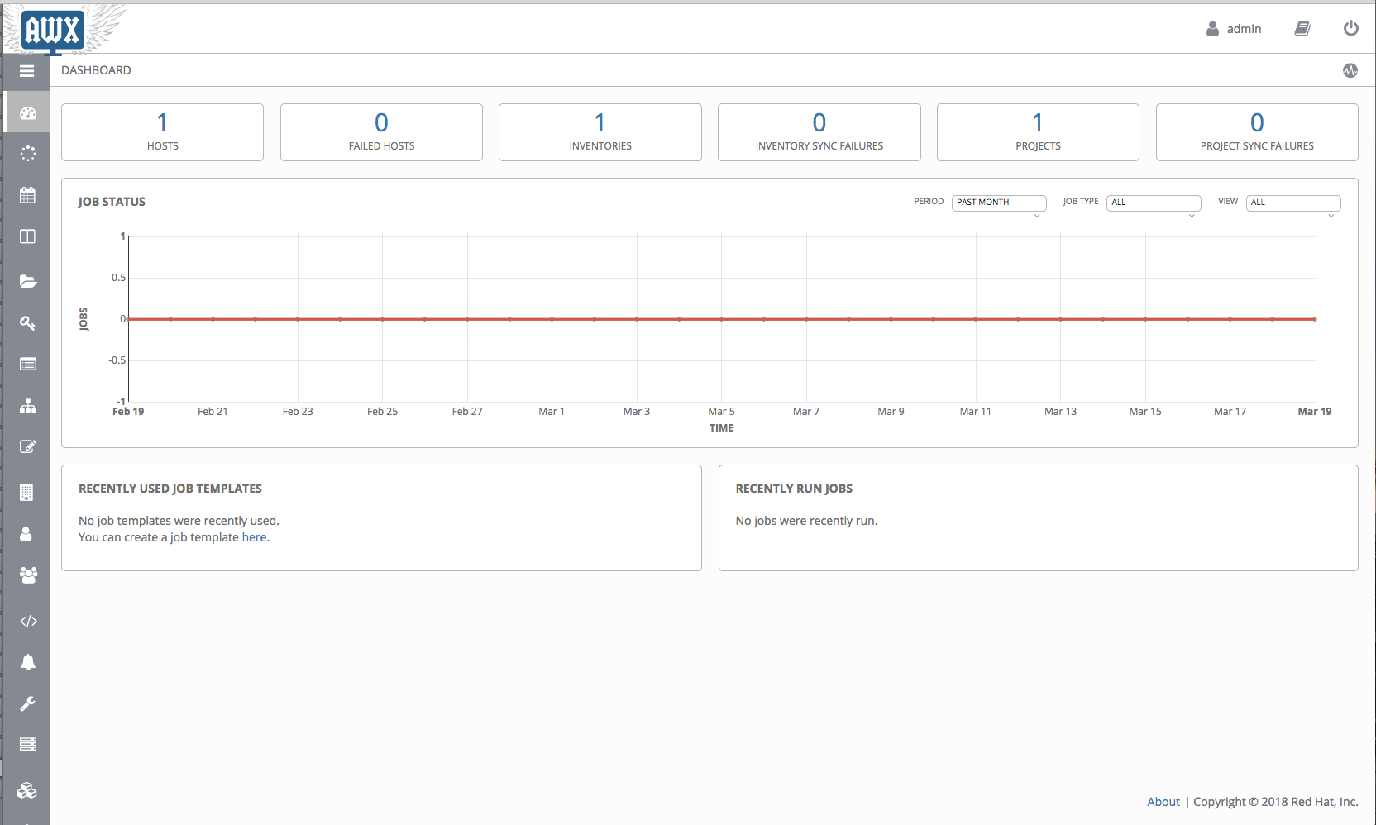

## Best Practices Using AWX on AWS

*Provide information about best practices for using the technology on AWS, including considerations such as migrating data, backups, ensuring high performance, high availability, etc. Link to software documentation for detailed information.*

## Security

*Discussion of security-related components, considerations, responsibilities, best practices.*

## <Other Useful Information>

*Provide any other information of interest to users, especially focusing on areas where AWS or cloud usage differs from on-premises usage.*

## FAQ

*Any tips or answers to anticipated questions. This could include the following troubleshooting information. If you don’t have any other Q&A to add, change this heading to “Troubleshooting” and remove the Q/A headings below.*

**Q.** I encountered a CREATE_FAILED error when I launched the Quick Start.

**A.** If AWS CloudFormation fails to create the stack, we recommend that you relaunch the template with **Rollback on failure** set to **No**. (This setting is under **Advanced** in the AWS CloudFormation console, **Options** page.) With this setting, the stack’s state will be retained and the instance will be left running, so you can troubleshoot the issue. (Look at the log files in %ProgramFiles%\Amazon\EC2ConfigService and C:\cfn\log.)

**Important** When you set **Rollback on failure** to **No**, you will continue to incur AWS charges for this stack. Please make sure to delete the stack when you finish troubleshooting.

For additional information, see [Troubleshooting AWS CloudFormation](https://docs.aws.amazon.com/AWSCloudFormation/latest/UserGuide/troubleshooting.html) on the AWS website.

**Q.** I encountered a size limitation error when I deployed the AWS Cloudformation templates.

**A.** We recommend that you launch the Quick Start templates from the location we’ve provided or from another S3 bucket. If you deploy the templates from a local copy on your computer or from a non-S3 location, you might encounter template size limitations when you create the stack. For more information about AWS CloudFormation limits, see the [AWS documentation](http://docs.aws.amazon.com/AWSCloudFormation/latest/UserGuide/cloudformation-limits.html).

## Git Repository

You can visit our [GitHub repository](https://github.com/aws-quickstart/tbd) to download the templates and scripts for this Quick Start, to post your comments, and to share your customizations with others.

## Additional Resources

*Additional reading, with full URLs. Revise the following as appropriate.*

**AWS services**

* Amazon EBS  
  <https://docs.aws.amazon.com/AWSEC2/latest/UserGuide/AmazonEBS.html>
* Amazon EC2  
  <https://aws.amazon.com/documentation/ec2/>
* Amazon VPC  
  <https://aws.amazon.com/documentation/vpc/>
* AWS CloudFormation  
  <https://aws.amazon.com/documentation/cloudformation/>

**AWX documentation**

* *Links for the technology that’s deployed by the Quick Start*
* <http://docs.ansible.com/ansible-tower/index.html>
* <https://www.ansible.com/products/awx-project/faq>

**Quick Start reference deployments**

* AWS Quick Start home page  
  <https://aws.amazon.com/quickstart/>

## Document Revisions

|  |  |  |
| --- | --- | --- |
| Date | Change | In sections |
| <month> 2017 | *Brief description of change. Formatting and minor text changes don’t warrant any mention; major additions and changes do.* | *Links to revised sections* |
| <month> 2017 | Initial publication | — |

© 2018, Amazon Web Services, Inc. or its affiliates, and <partner organization>. All rights reserved.

**Notices**

This document is provided for informational purposes only. It represents AWS’s current product offerings and practices as of the date of issue of this document, which are subject to change without notice. Customers are responsible for making their own independent assessment of the information in this document and any use of AWS’s products or services, each of which is provided “as is” without warranty of any kind, whether express or implied. This document does not create any warranties, representations, contractual commitments, conditions or assurances from AWS, its affiliates, suppliers or licensors. The responsibilities and liabilities of AWS to its customers are controlled by AWS agreements, and this document is not part of, nor does it modify, any agreement between AWS and its customers.

The software included with this paper is licensed under the Apache License, Version 2.0 (the "License"). You may not use this file except in compliance with the License. A copy of the License is located at <http://aws.amazon.com/apache2.0/> or in the "license" file accompanying this file. This code is distributed on an "AS IS" BASIS, WITHOUT WARRANTIES OR CONDITIONS OF ANY KIND, either express or implied. See the License for the specific language governing permissions and limitations under the License.

# Style Guide

Delete this section after following these guidelines.

## Terminology and usage

* For a word list and usage guidelines for AWS content, see the [AWS Usage Dictionary](https://alpha-docs-aws.amazon.com/awsstyleguide/latest/styleguide/dictionary.html) (internal AWS use only).
* For AWS service names and allowed variations, see the [AWS Service Names](https://w.amazon.com/bin/view/AWSDocs/editing/service-names/) wiki page (internal AWS use only).

## Bullet lists

* Use the **List Bullet** style instead of using the bullets control on the Word ribbon.
* Use the **List Paragraph** style for additional paragraphs under the bullet.
* Use nested bullet lists sparingly.

Use the **List Bullet 2** style for second-level bulleted lists.

Keep both first-level and second-level lists short. Three to seven items is a good rule of thumb to follow.

Because bullet lists have less spacing after each paragraph, consider manually changing the spacing after the last item to 14 pt.

## Numbered lists for procedures

1. Use a numbered list only when there’s a sequence (of steps, or priorities, etc.) involved.
2. Use the **List Number** style instead of using the numbered list control on the Word ribbon.
3. Use the **List Paragraph** style for additional paragraphs under the number.
4. Use nested lists sparingly.
5. Use the **List Number 2** style for second-level numbered lists.
6. Because numbered lists have less spacing after each paragraph, consider manually changing the spacing after the last item to 14 pt.

## Tips, Notes, Warnings

Use the **Note** style, which provides the following formatting. Change “Note” to “Tip” or “Warning” as needed.

**Note** You are responsible for all costs incurred by your use of the AWS services used while running this Quick Start Reference Deployment. See the pricing pages of the specific AWS services you will be using for full details.

## Figures

* Use the **Picture** style, which centers the illustration.
* Below the figure, add the figure caption using the **Caption** style. Specify the number in the format **Figure *n*: Caption**. Use sentence capitalization for captions (that is, just capitalize the first word and any proper nouns).
* For architecture diagrams, use the [Visio](https://github.com/aws-quickstart/quickstart-examples/raw/master/doc/Quick%20Start%20architecture%20diagram.vsdx) or [PowerPoint](https://github.com/aws-quickstart/quickstart-examples/raw/master/doc/Quick%20Start%20architecture%20diagram.pptx) templates we provided, and the [AWS simple icons](https://aws.amazon.com/architecture/icons/), and please send us the source file.

## Tables

* Create a table in Word (**Insert** > **Table**), and apply the **AWS** table style from the menu on the **Table Tools**, **Design** tab. There’s also an **AWS wide** style if you need a wider table.
* Use the **Table text** style for the contents of the table.
* Add boldface for headings.
* Turn on the **Repeat Header Rows** option on the **Table Tools**, **Layout** tab.

|  |  |  |  |  |
| --- | --- | --- | --- | --- |
|  | January | February | March | April |
| North | Red | Green | Blue | Black |
| South | Red | Green | Blue | Black |
| East | Red | Green | Blue | Black |
| West | Red | Green | Blue | Black |

## References

* Use the **Hyperlink** style.
* Use the title of the paper or website as link text. Don’t use phrases like “click here” or “this website” for your links.
* In some cases, you might want to shorten the link text and weave it into the sentence, e.g., “Create a [key pair](http://docs.aws.amazon.com/AWSEC2/latest/UserGuide/ec2-key-pairs.html) in your preferred region.”
* Don’t display the URL in text (unless you’re linking to a home page or to a main section under the home page), but make sure to include the full title and URL in the “Additional Resources” section.
* When providing information from other sources, be sure to use your own words. Use short quotations if necessary. It’s OK to use text from the AWS documentation.

## Code

For code that appears within a sentence, use the Code Inline style.

For code blocks, use the **Code Snippet** style:

"Conditions": {

"GovCloudCondition": {

"Fn::Equals": [

{

"Ref": "AWS::Region"

},

"us-gov-west-1"

]

}

},

In the HTML version of the deployment guide, we can use syntax highlighting for selected languages, including JSON, PowerShell, Bash, and Python. The PDF format doesn’t support syntax highlighting.

## Sidebars

**Create Sidebars with an Inset Text Box**You may have to apply a text wrap to your text box. The Square option is usually best. Avoid using multiple paragraphs.

If you want to use a sidebar to highlight content, create a text box (**Insert** > **Text Box**) and style the text inside as **Side Body**. There is no heading style, so if you want to add a heading, style it as **Side Body** and then manually apply the bold attribute.

Avoid using multiple paragraphs, because these are converted to separate text boxes in the PDF. (You can use soft returns to work around this limitation.)

## Colors

When you need to use color, select from the following color palette.

|  |  |  |  |  |  |  |
| --- | --- | --- | --- | --- | --- | --- |
|  |  |  |  |  |  |  |
| R: 242  G: 165  B: 44 | R: 178  G: 36  B: 145 | R: 0  G: 124  B: 188 | R: 139  G: 201  B: 66 | R: 0  G: 0  B: 0 | R: 166  G: 166  B: 166 | R: 89  G: 89  B: 89 |